Koncept PCB Assembly Correction:

Only the marked 2 components need to be rotated.

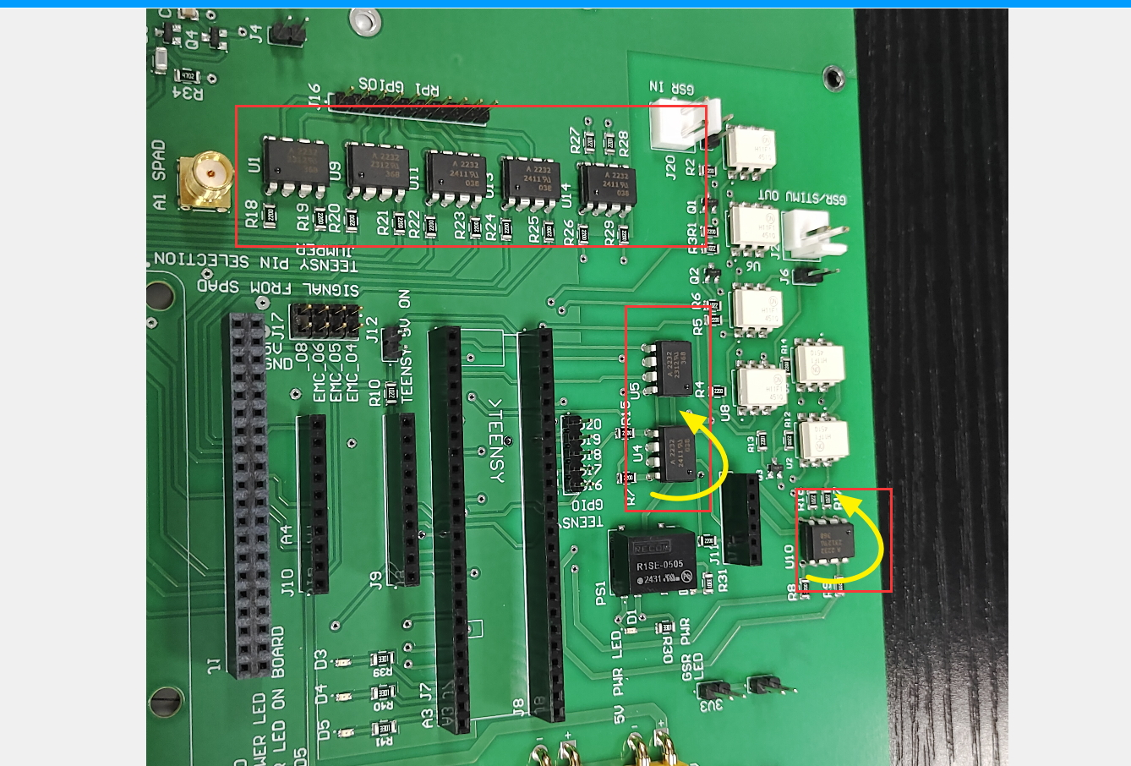

Teensy Physical pin 48 Should be 5V in and Pin 47 should be GND. This board has error that it swapped .

Measure the 5V in connection continuity and correct the connection from top side and bottom side.

